Homework 2
Rohan Krishnamurthi
10/25/2024

Part A:
- Build an index for the yeast reference genome with STAR.
  - Complete: run script in Ensembl folder.
  - Project directory: /projects/e31265/ensembl/
- Align one biological replicate (from the six). Complete

First wildtype: ERR458878, ERR458879, ERR458880, ERR458881, ERR458882, ERR458883, ERR458884

- Run script hw_2.2.sh. Complete.
- Run script hw_2.3.sh (ending 01). Complete.
- Run script hw_2.4.sh (ending 04). Complete.
- Use multiQC to create a plot of results. Complete and saved in folder.

File: hw_2_multiqc_report.html
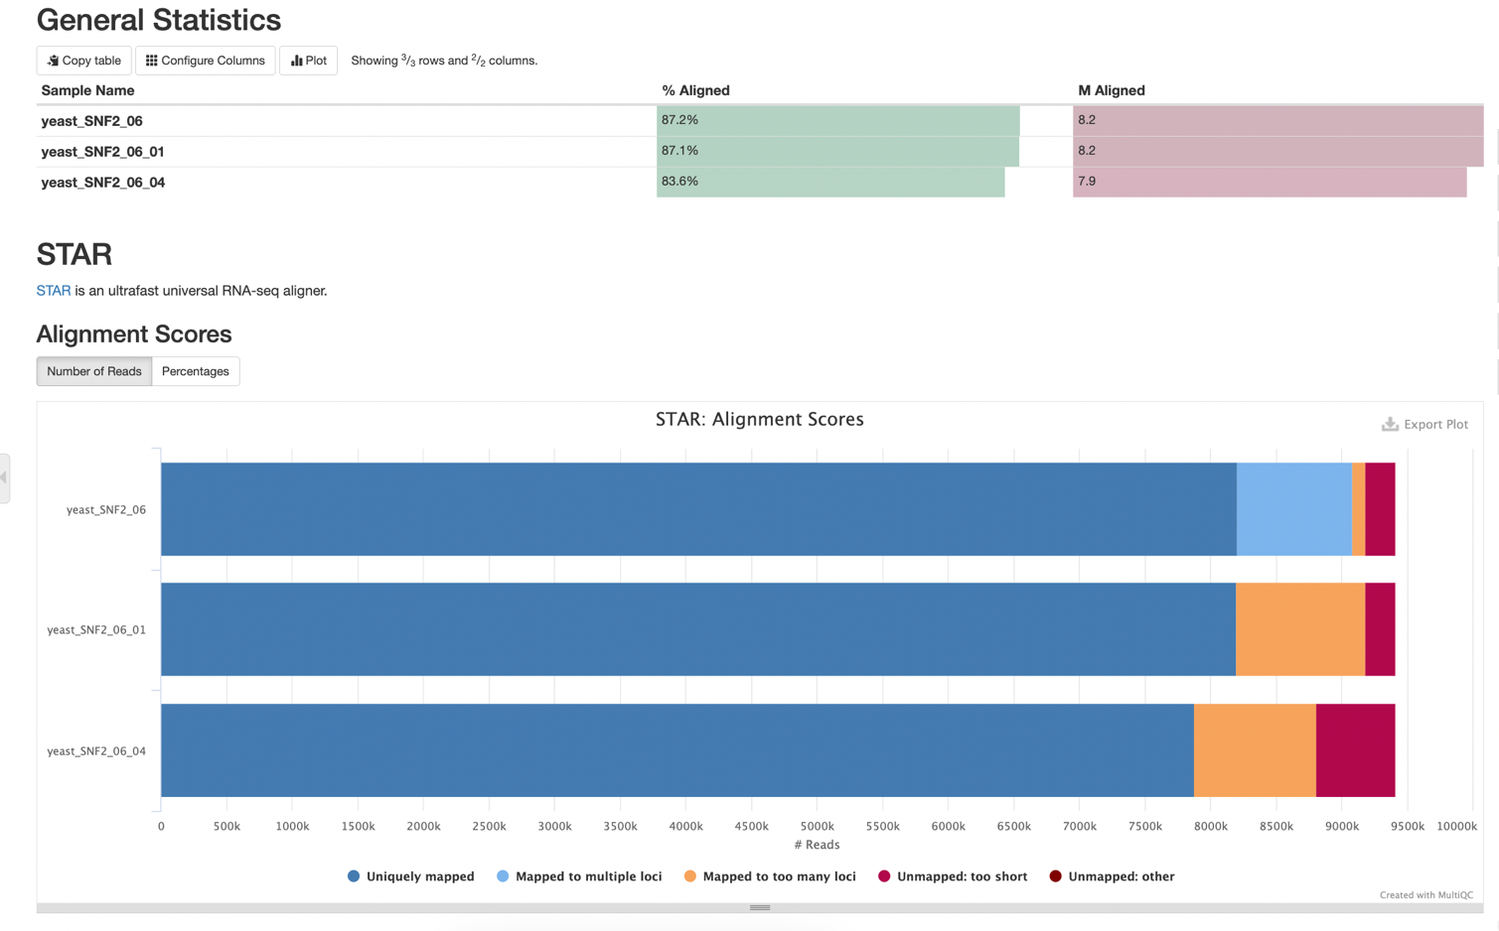

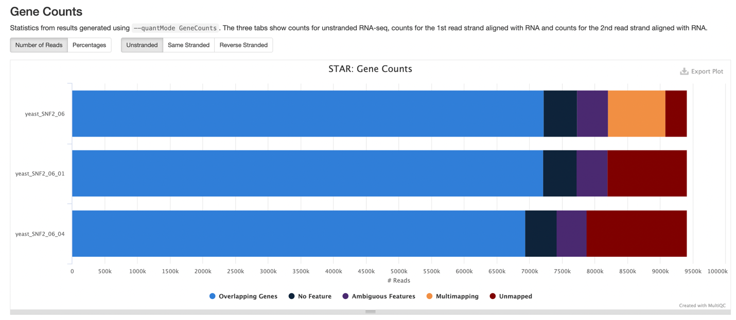

Discussion: The reads align quite strongly, as roughly 87% of the reads align. The STAR option outFilterMultimapNmax 1 has very little impact on the number of reads aligned, while the filter outFilterScoreMinOverLread 0.95 has a significant impact on the number of reads aligned, as it decreases by 3.5%. The first filter completely eliminates the reads that map to multiple loci, and it reclassifies these reads as reads that map to too many loci. The second filter decreases the number of uniquely mapped reads, and it increases the number of unmapped (too short) reads.

Part B:
- Open IGV and select yeast genome.
- Open the three BAM files in IGV.
- Set preferences. Complete.
- Get information about reads.
- View, preferences, alignments.
Tasks
- View reads at locations in the genome.
- Location where reads are present in the BAM file with default settings, but not the BAM file with option outFilterMultimapNmax 1.
- Save an image of the location: chrXV:853,785-855,523 (gene is SNF2).
Explanation: The option --outFilterMultimapNmax 1 causes only reads that map uniquely to the genome to be output. This filter removes all reads that map to multiple locations within the genome.
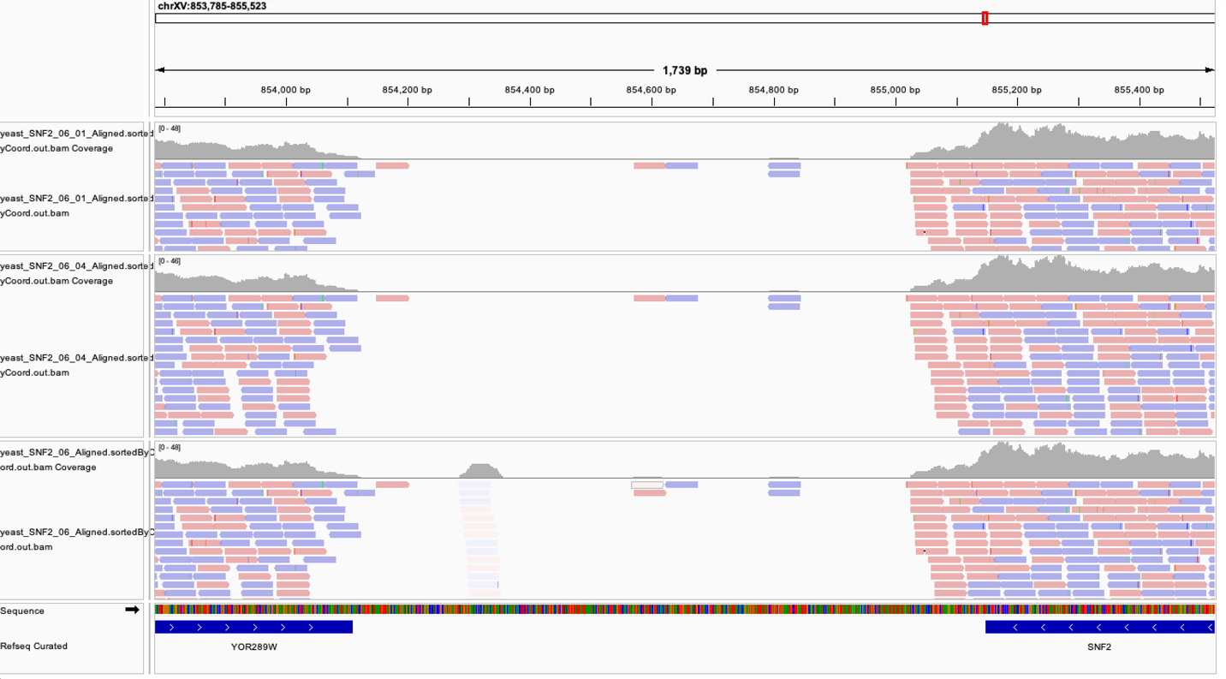
- Location where reads are present in the BAM file with default settings and BAM file with option outFilterMultimapNmax 1, but not file with outFilterScoreMinOverLread 0.95.
- Save an image of the location: chrXV:874,155-874,589 (gene is TPO4).
Explanation: The option –outFilterScoreMinOverLread 0.95 causes only reads that score a minimum of 0.95 times the read length to be output. All reads that score less than 0.95 times the read length are removed with this filter.

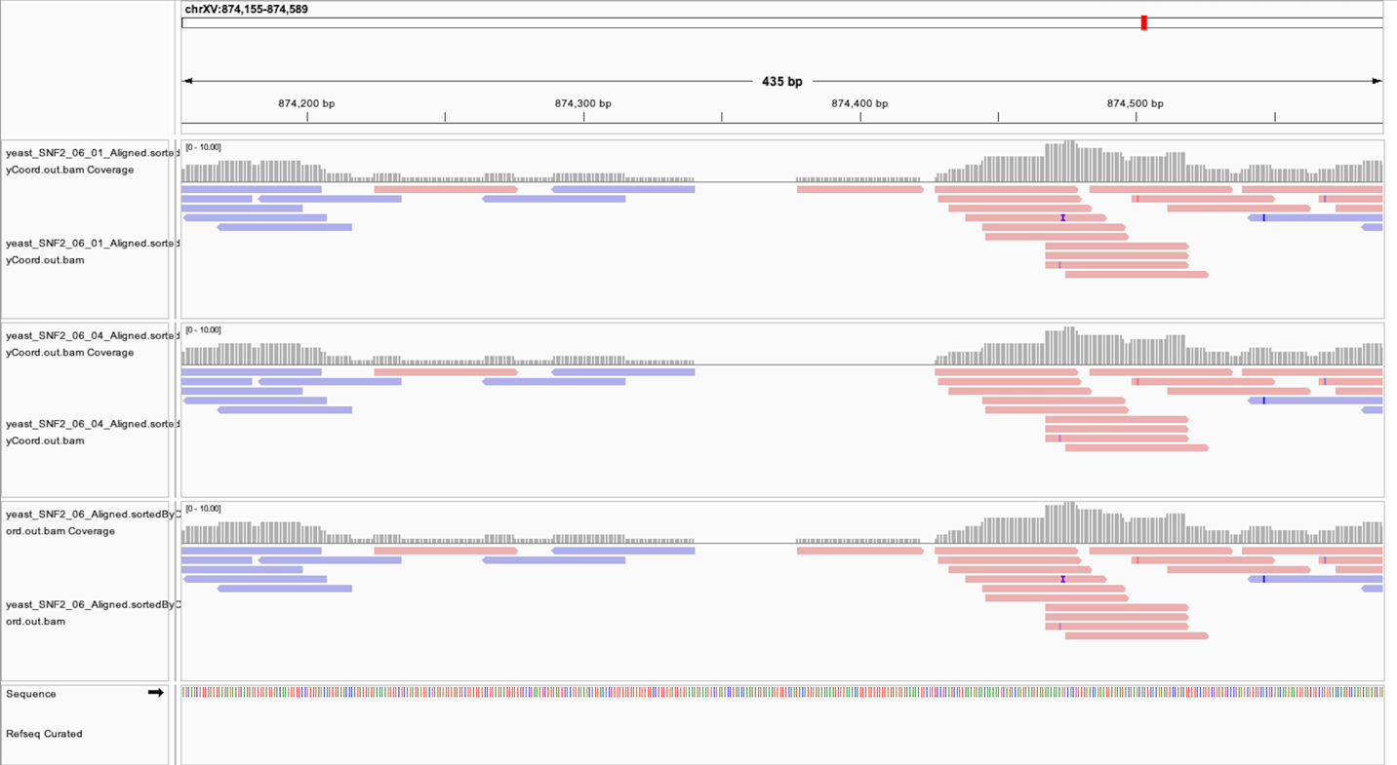

- Find an insertion in the first BAM file.
- Save an image of the location: chrIII:128,116-128,619.
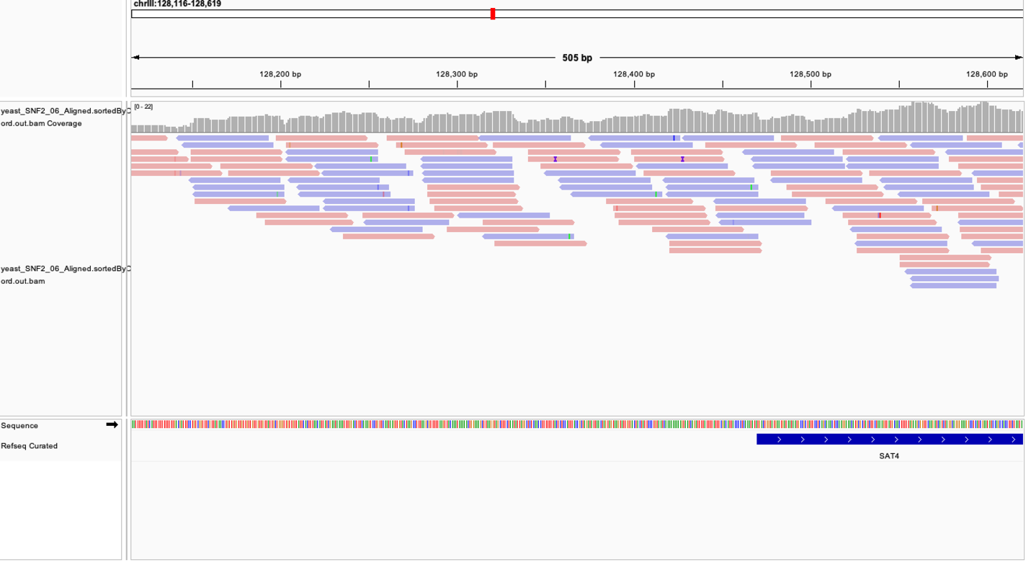
- Identify location of a deletion. Command: samtools view yeast_SNF2_06_Aligned.sortedByCoord.out.bam | awk '$6 ~ /D/ { print $0 }'
- Save an image of the location: chrII:59,901-59,940.
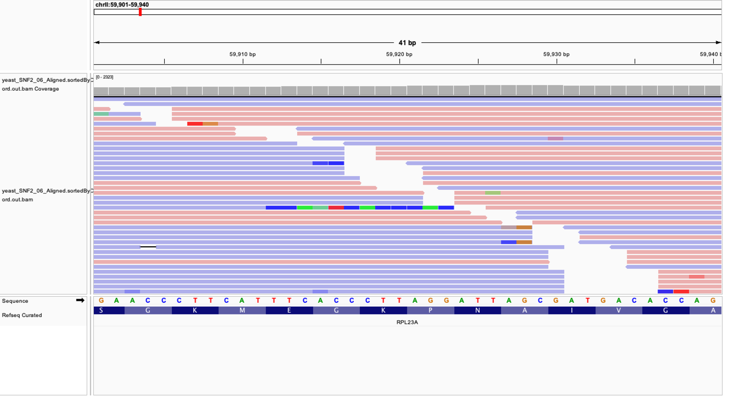
- Identify location with spliced reads.
- Save an image of the location: chrXI:109,554-109,593.

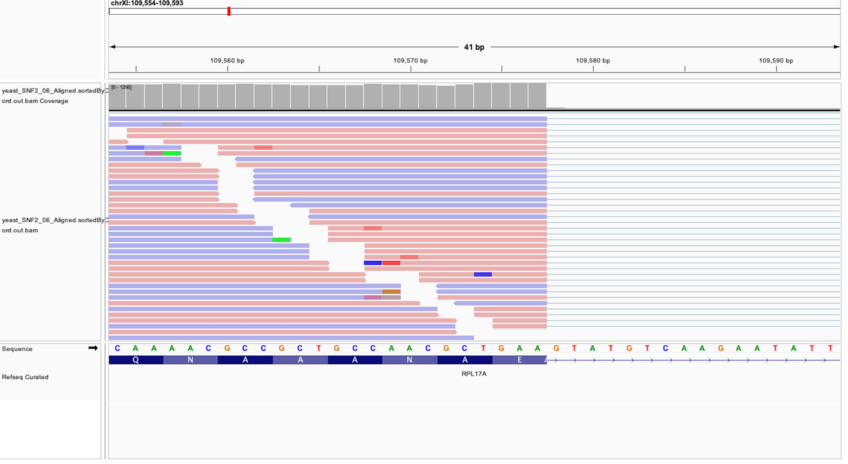
- Read Scores:
  - First file: yeast_SNF2_06_Aligned.sortedByCoord.out.bam range of 32 to 53

AS:i:32 | 47
AS:i:33 | 2302
AS:i:34 | 2471
AS:i:35 | 2383
AS:i:36 | 3061
AS:i:37 | 2731
AS:i:38 | 3737
AS:i:39 | 3101
AS:i:40 | 5031
AS:i:41 | 4199
AS:i:42 | 11302
AS:i:43 | 9321
AS:i:44 | 37117
AS:i:45 | 29238
AS:i:46 | 294042
AS:i:47 | 192321
AS:i:48 | 1987963
AS:i:49 | 326669
AS:i:50 | 7148759
AS:i:51 | 64560
AS:i:53 | 26

  - Second file: yeast_SNF2_06_01_Aligned.sortedByCoord.out.bam range of 33 to 53

AS:i:33 | 1736
AS:i:34 | 1903
AS:i:35 | 1841
AS:i:36 | 2314
AS:i:37 | 2041
AS:i:38 | 2844
AS:i:39 | 2319
AS:i:40 | 3681
AS:i:41 | 3286
AS:i:42 | 9053
AS:i:43 | 7640
AS:i:44 | 29612
AS:i:45 | 23910
AS:i:46 | 235153
AS:i:47 | 151309
AS:i:48 | 1600744
AS:i:49 | 256340
AS:i:50 | 5803395
AS:i:51 | 63064
AS:i:53 | 63064

  - Third file: yeast_SNF2_06_04_Aligned.sortedByCoord.out.bam range of 47 to 53
AS:i:47 | 151309
AS:i:48 | 1600744
AS:i:49 | 256339
AS:i:50 | 5803395
AS:i:51 | 63064
AS:i:53 | 26

- Find location with highest score possible: chrIV:1,319,594-1,319,633.
File: yeast_SNF2_06_Aligned.sortedByCoord.out.bam